Aeronautics Workbook

Ben Woods

This document provides a series of worked examples of Aeronautics questions that span the range of content you will be expected to be able to understand and implement, in the order that they appear in the course. That’s not to say of course that the exam questions will only look like what is here, but if you are comfortable with these questions you should do well on the exam.

During 2025 this document will grow week on week as the relevant material is taught.

### 1. The Fairchild C-119 Flying Boxcar is a propeller driven, radial engine transport aircraft. It has a reference wing area of S = 134.4 m2 and a mass of 29,000 kg.

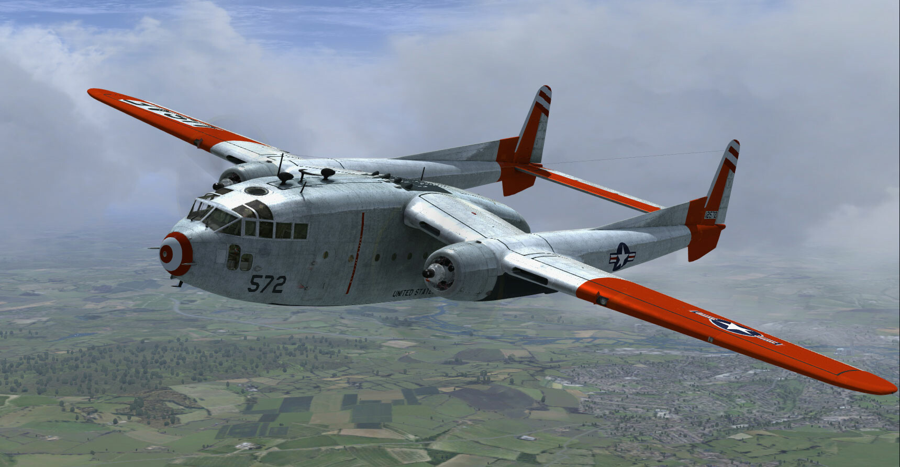

#### What lift coefficient does the wing need to generate if the aircraft is flying in steady level flight at a speed of 90 m/s at sea level?

#### If we assume a lift curve slope for this aircraft of *a* = 2π/rad, and a zero-lift angle of incidence of , what angle of attack will it need to fly at?

First, let’s work this problem in degrees instead of radians:

But :

#### If we instead want to fly at a lift coefficient of CL = 0.5, what speed is required to maintain steady level flight?

#### If the aircraft has a stall speed of 45.6 m/s, estimate CL,max .

### 2. Consider an aircraft flying at sea level with a mass of 78,000 kg, a planform area of *S* = 120 m2, an aspect ratio of *AR* = 9, a span efficiency factor of *e* = 0.85, and *CD,0* = 0.028.

#### a. Find the aircraft’s drag force when flying at *V* = 160 m/s

#### b. If the wing were very carefully redesigned to produce a perfect span efficiency factor *e* = 1, by what percentage would the drag reduce?

#### c. If, instead, the aspect ratio was increased to *AR* = 14 but the original value of *e* = 0.85 was retained, by what percentage would that reduce the drag?

### 3. A Spitfire-esque aircraft has a mass of *m* = 3,040 kg, a planform area of *S* = 22.5 m2, a span efficiency factor of *e* = 0.87, *CD,0* = 0.020, and an aspect ratio of *AR* = 5.6.

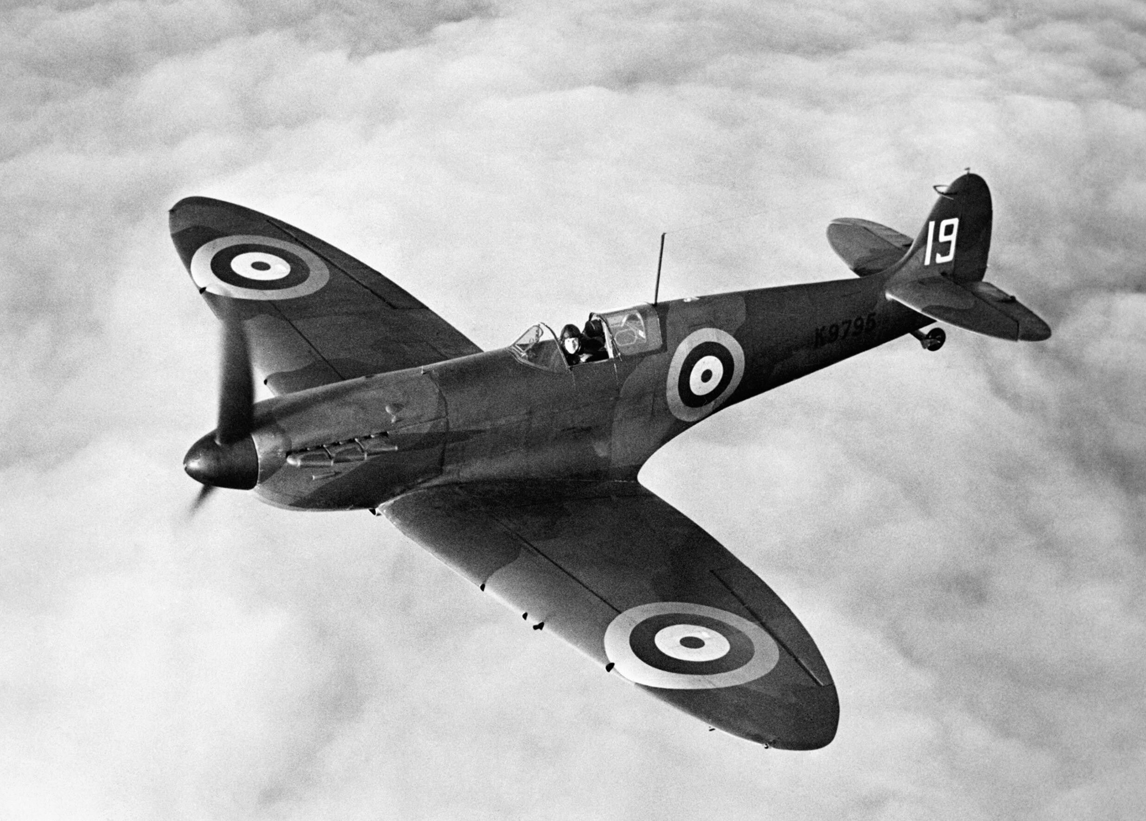

#### a. What *CL* does the aircraft need to generate to fly at a speed of 100 m/s at sea level?

#### b. What is the total drag force at this speed and altitude? What percentage of that total is induced drag?

#### c. What *CL* is needed if the aircraft is instead flying at an altitude of 10,000 m?

#### How does the total drag change when at 10 km? What about the percentage of drag that is induced?

Here we see the competing impacts of air density on flight performance. In the first instance, there is a direct reduction in drag created by the reduced air density at altitude, however, that same reduction in air density means the wing has to work the less dense air harder in order to maintain lift (since we have fixed velocity). This increase in required lift coefficient then impacts the drag by increasing the induced drag coefficient. In this case the net effect on overall drag is that it more than doubles despite the ~60% decrease in air density. We see this also reflected in the fact that induced drag has increased from 13.3% of the total to 57.9%.

### 4. Consider an ATR-72 regional turboprop aircraft flying at an altitude of 8000 m with the following characteristics: mass *m* = 20,000 kg, planform area *S* = 61 m2, aspect ratio *AR* = 12, Oswald efficiency *e* = 0.78, zero lift drag coefficient *CD0* = 0.024 .

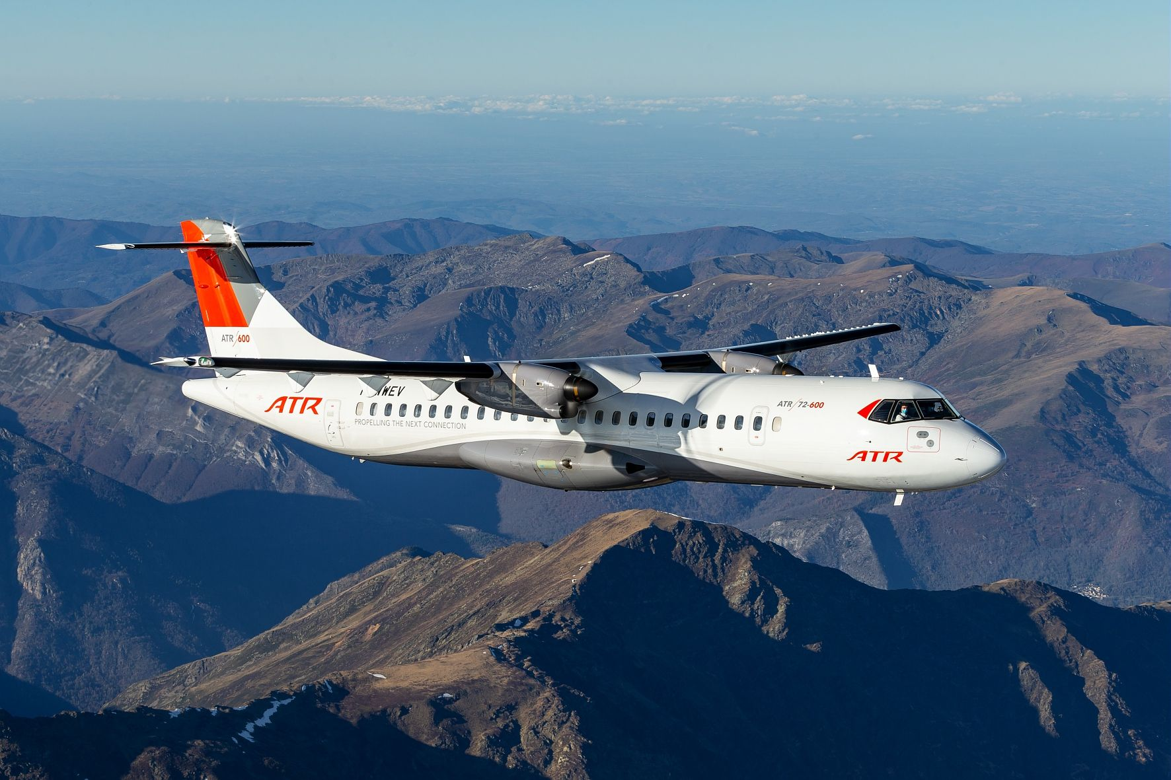

#### a. What is the minimum drag speed of this aircraft?

We know the minimum drag condition occurs when:

Solving for *CL*

We need to find the induced drag term *K*

Then

We can find velocity from *CL*, but we first need to find the air density at this altitude

#### b. What is the equivalent airspeed for the answer to (a).?

Which is to say that due to changes in air density with altitude, this aircraft flying at 121 m/s at an altitude of 8km generates the same loads as when it flies at 79 m/s at sea level.

#### c. What is it’s minimum power speed?

We know the minimum power condition occurs when:

Solving for *CL*

We can then find *VMP*

#### d. How much additional power does it require to fly at its minimum drag speed compared to the minimum power case?

We will first find the power required for the minimum drag case

We start by remembering the condition for minimum drag

We now repeat for minimum power

Using the condition for minimum power

Therefore, flying at the minimum drag speed requires 166kW of additional power (14%) compared to flying at the minimum power speed.

### 5. The Cessna 172 is the most produced aircraft in history, with more than 44,000 examples made to date. Assuming it has the following properties: *m* = 1,100 kg, *S* = 16.2 m2, L/D = 10.9, *AR* = 7.32, *CD,0*= 0.032, and an Oswald efficiency factor *e* = 0.7. Imagine it is flying at 5,000m altitude when its engine fails and it enters gliding flight. Calculate:

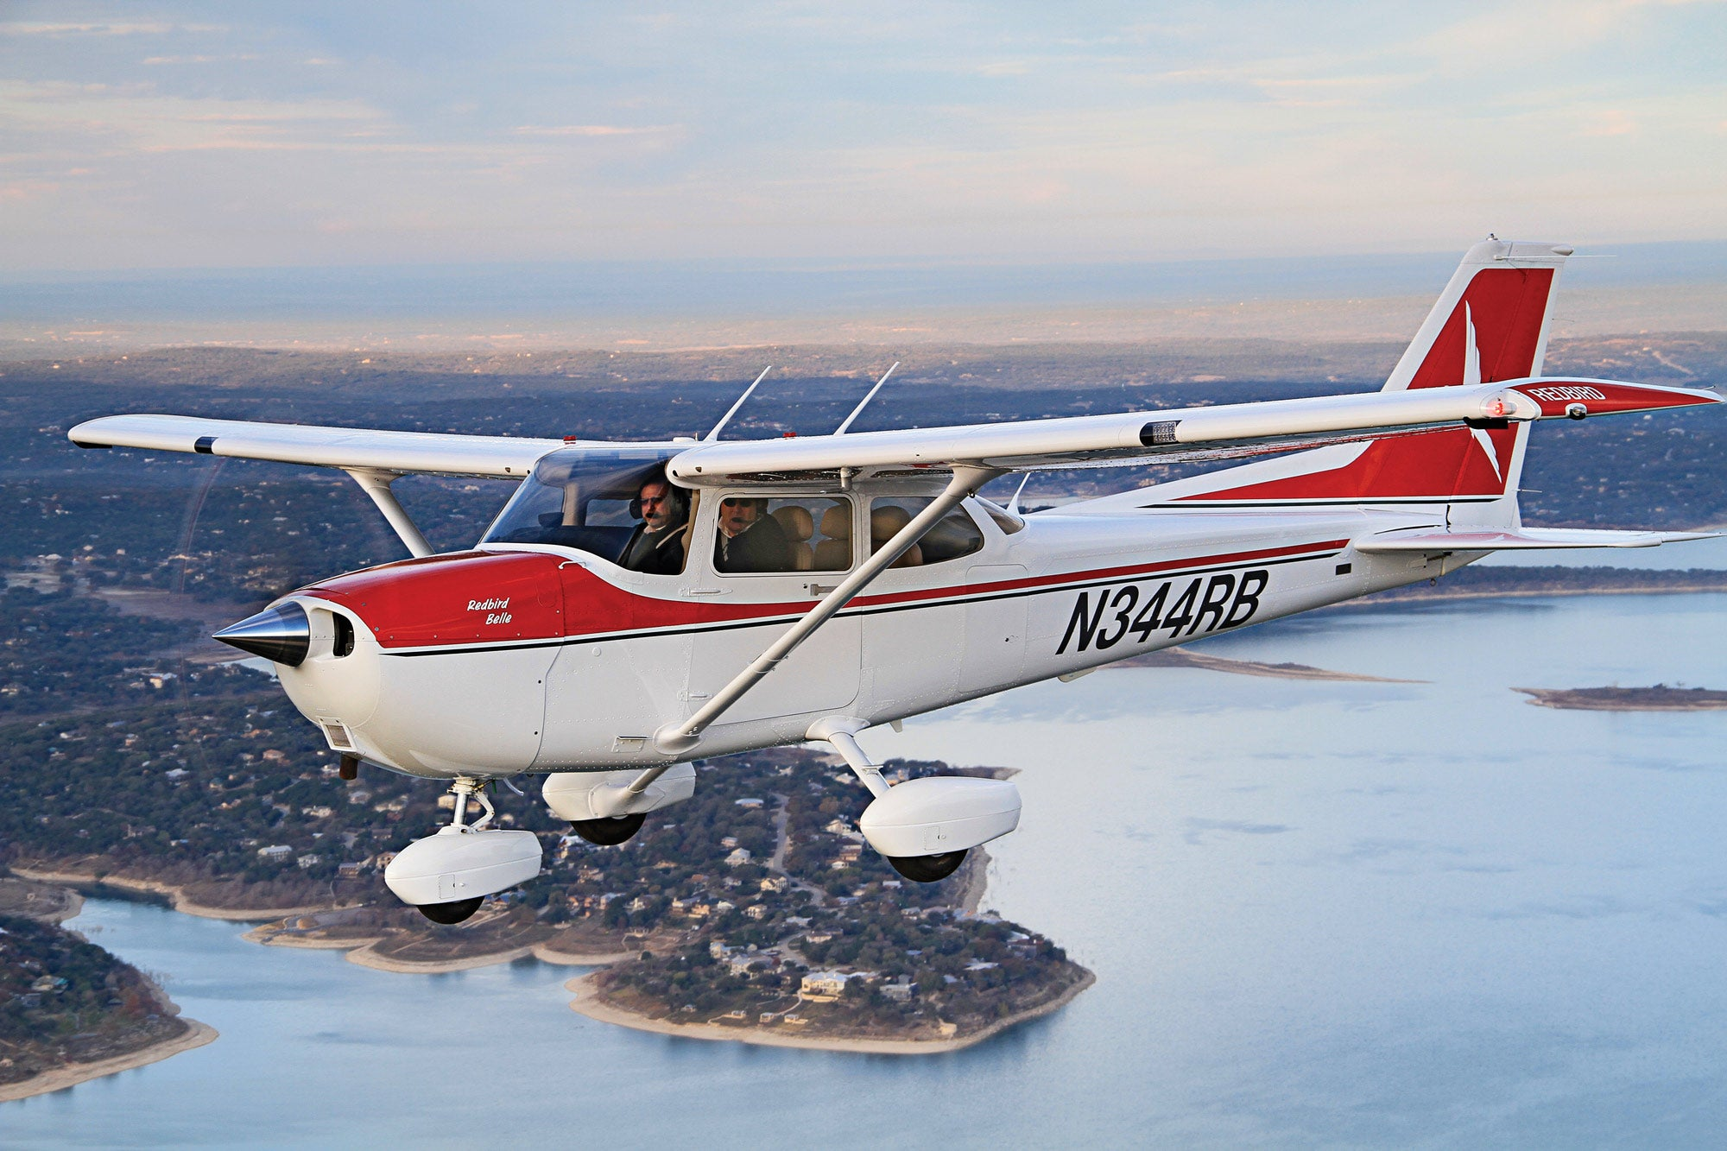

#### a. The minimum glide angle and flight speed to achieve it.

We then recall that min glide angle occurs at the minimum drag speed, where we know

We need to find the induced drag term *K*

Then we can find the lift coefficient

Find the air density at 5,000 m

We can then find the speed

#### b. Speed to fly at to minimise sink rate, and the corresponding sink rate

We know the minimum sink rate occurs at the minimum power condition, where the lift coefficient is:

We can then find *VMP*

The sink rate can be found from

But for this we need the drag coefficient, which we also know for the minimum power condition to be

We can now find the sink rate

### 6. The DC-3 is a propeller powered airliner with an OEW = 7,650 kg, MTOW = 11,400 kg, a maximum fuel capacity of 2,690 kg, and a maximum payload of 2,700 kg. It has a wing area of *S* = 91.7 m2, *CD,0* = 0.0299, *K* = 0.0486, a propeller efficiency of *η* = 0.74, and a power specific fuel consumption of *f* = 1.13x10-7 kg/(W·s). Of all of the airplanes, it is one of the most airplaney.

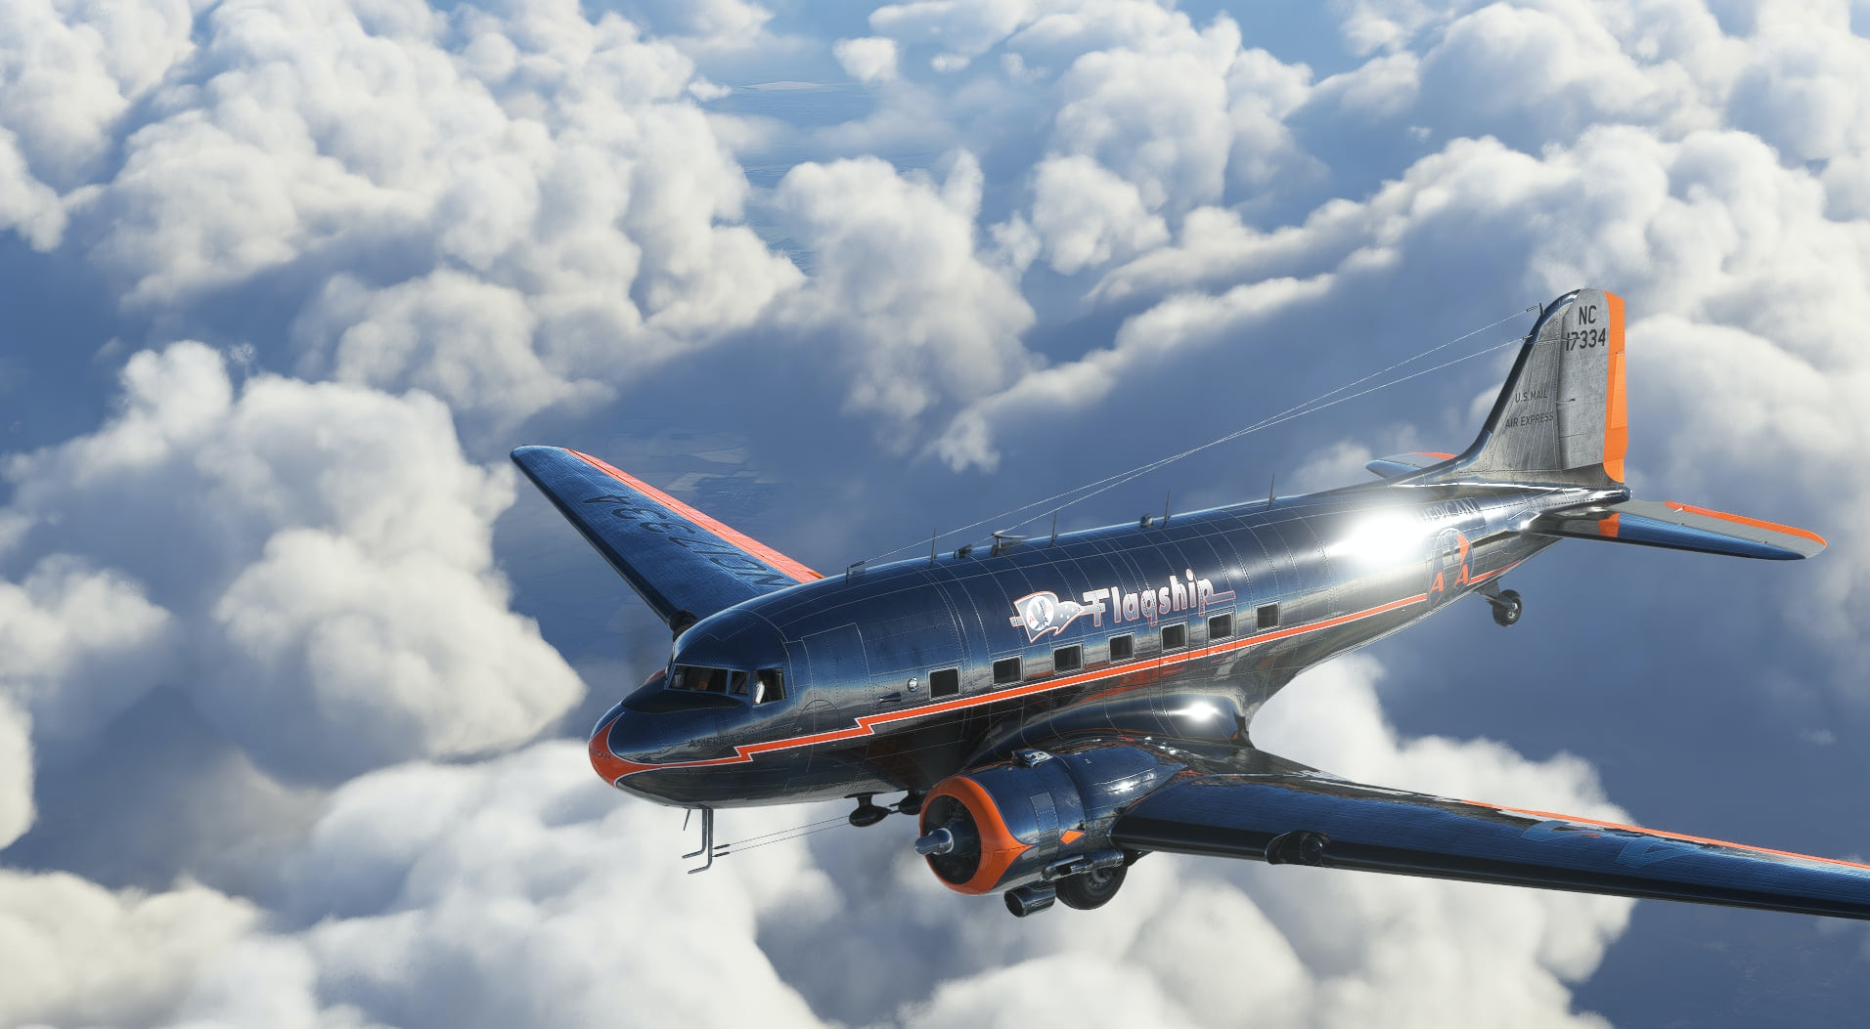

#### a. Sketch the payload range diagram for this aircraft, including calculated values for the relevant vertices.

We need to find three points to define the payload range diagram:

p1. Maximum range at MTOW with maximum payload

p2. Maximum range at MTOW with maximum fuel

p3. Maximum ferry range – maximum fuel, no payload

All three of these will occur at the flight condition for best range, which for propeller aircraft occurs at the minimum drag condition:

We now solve the propeller version of the Breguet range equation for each scenario:

p1. Maximum range at MTOW with maximum payload

p2. Maximum range at MTOW with maximum fuel

We also need to know the corresponding payload in order to plot this point on the payload range diagram:

p3. Maximum ferry range

We can now sketch the Payload-Range diagram:

(ok I cheated and used Matlab, but a pencil sketch would be fine for an exam)

#### b. Calculate the endurance of this aircraft with maximum fuel and a payload of 500 kg at an altitude of 2000 m.

We know that for propeller powered aircraft, maximum endurance will occur at the minimum power condition:

The relevant weights will be:

We also need to know the corresponding velocity (ask yourself why the prop version has an extra 1/velocity term), but first we find the air density at this altitude:

### 7. Consider a jet aircraft with a total mass of *m* = 115,000 kg, a wing area *S* = 224 m2, that is carrying 35,000 kg of fuel. It has a *CD0* = 0.03, an induced drag term of *K* = 0.04, and a thrust specific fuel consumption of *f* = 1.8x10-5 kg/(N·s).

#### a. Calculate the velocity, thrust, power and range for this aircraft when flying at the condition for maximum range, assuming that it is starting at 11 km altitude and must keep 10% of its fuel in reserve.

In order to maximise the range of jet aircraft, we fly at the following condition:

We find velocity using this lift coefficient, but we first must find the air density scaling factor for 11 km altitude:

Drag force and Power can then be found:

For the range calculation we need the initial and final weights:

#### b. If it instead started at sea level, what is the % decrease in maximum range (again assuming 10% fuel reserve)?

The condition for optimality (CL and CD) doesn’t change, but due to the change in air density, the velocity we fly at to achieve this condition will change:

This is much slower than the 11 km case! Now we find the corresponding range:

#### c. Calculate the maximum flight endurance at 5 km altitude (no fuel reserve).

To maximise jet aircraft endurance, we fly at the minimum drag condition:

For the endurance calculation we need the initial and final weights:

Note that even though we are not flying at sea level, the answer does not actually depend on air density because this version of the endurance equation does not explicitly include velocity. The velocity you would fly at to achieve the required CL value, and therefore this value of endurance, would of course depend on altitude however.

### 8. Consider again our Spitfire-esque aircraft, which has a mass of *m* = 3,040 kg, a planform area of *S* = 22.5 m2, a span efficiency factor of *e* = 0.87, a maximum load factor of nmax = 2.34, *CD,0* = 0.020, and a maximum lift coefficient of CL,max = 1.35. It is flying at sea level, calculate:

#### The velocity this aircraft should fly at to maximise its manoeuvring performance.

We know that the best manoeuvre performance (i.e. minimum radius and turn time) occur when we fly at the manoeuvre point, with both load factor and lift coefficient maximised, which will happen at the corner velocity:

#### Its minimum turn radius and its minimum time to turn 180°.

#### c. Maximum achievable steady bank angle.

#### d. If the Spitfire had flaps which could increase CL,max by 0.5, find how much less time it would take the aircraft to complete a 180° turn.